UCLG
UCLG GOLD website administration

Version
1.0.3

Writer

Jacques Bonet

Last update : 31/01/2012
Contents

1 - Historic 4
2 - Introduction 5
3 - Users and groups administration 5
3.1 - Administrators/Publishers 5
3.2 - Identifiers 7
3.2.1 - Administration guideline 8
3.3 - Web site provider 8
3.4 - Access Management 8
3.4.1 - Articles access right 8
3.4.2 - Modules access right 8
4 - Categories/Articles management 9
4.1 - Joomla hierarchy 9
4.2 - Articles hierarchy visibility 9
4.2.1 - On the back end 9
4.2.2 - On the front end 9
4.2.3 - Articles naming convention 10
5 - Articles creation on the front end 10
6 - Services management 11
6.1 - Key indicators and link database management 11
6.2 - Country Profiles 12
6.3 - Gold Reports 14
6.3.1 - Naming conventions 14
6.3.2 - Displaying PDF contents 14
6.3.3 - Use multiples pdf 16
6.3.4 - Use one pdf 17
7 - Multilang 18
8 - Joomla system administration 18
8.1 - Joomla upgrade 18
8.2 - Joomla Configuration 18
8.2.1 - Cache management 19
8.2.2 - URL rewriting 19
8.3 - Joomla extensions 19
8.3.1.1 - Components extension 19
8.3.1.2 - Plugins extension 19
8.3.1.3 - Modules extension 19
8.3.2 - ExtJS 20
9 - Banners update 20
10 - Implementation 22
10.1 - Services oriented PHP code 23
10.2 - Regions management 23
10.2.1 - Categories list 24

- Historic
Date | Auteur | Version | Modification
15/01/2012 | Bonet Jacques | 1.0 | Création
16/01/2012 | Bonet Jacques | 1.0.1 | Update
29/01/2012 | Bonet Jacques | 1.0.2 | Article creation
31/01/2012 | Bonet Jacques | 1.0.3 | Article creation update

- Introduction
The purpose of this document is to describe the administration of the web site www.uclggold.org
The web site is made with Joomla 1.7.3. We considere the reader has a good understanding of Joomla. If not, some tutorials could be fund on the web site www.joomla.org

- Users and groups administration
First we focus to the administration of the users and group.

  - Administrators/Publishers
To ease the management of administrators and publishers, Joomla has the notion of users group. The group used in uclggold website are :
- One Super administrator
- One administrator for world region : Administrator
- One administrator by region : example Admi Africa
- One publisher for world region : Publisher
- One publisher by region : example Publisher Eurasia
We have 8 regions : africa, asia-pacific, europe, north-america, latin-america, euro-asia, east-orient, world. So we have 8 administrator group + 8 publisher group + one super user group.

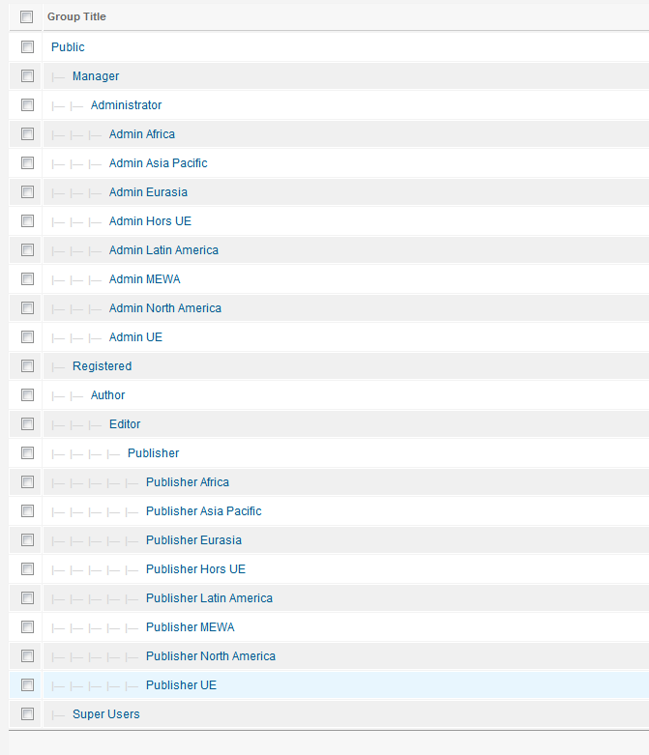

One user Administrator and Publisher have been created for each of these group.
For example one user for administrator group “Admin North America”.

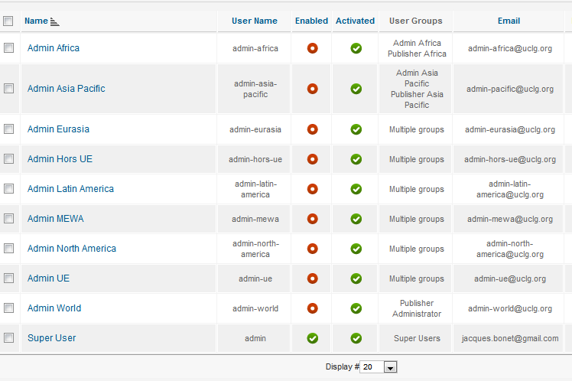

  - Identifiers
To connect to the administration web site (back end), enter the url www.uclggold.org/administrator.

The login for the super admin ise :
Login : admin
Pass : AZErty123
Default administrators have been created for each region.

The login and pass for these administrators are :
- Login : admin-XXX where XXX is the region name (ex : admin-africa, admin-asia-pacific)
- Pass : AZErty123

There email address are <user name>@uclg.org, exemple admin-eurasia@uclg.org

Nota : The email address have not been created.

    - Administration guideline

Its not a good idea to use directly the default administrators already created by the system, because the administrator name is not nominative, so no possibility to identify who is connected to the system. Its why these user group have been disabled. There where created only for test purpose.

The best thing to do is to create real user (ex : Jacques Bonet), and assign to this user a group (ex Admin Africa)

  - Web site provider

The web site is hosted by www.siteground.com provider.
To administrate the domain www.uclggold.org, connect to www.siteground.com and use the following identifier :
Login : uclgcglu
Pass : lahaya

  - Access Management
Joomla is composed of categories, articles, modules and components. It is possible to define access right to theses components according the user group created.

    - Articles access right
The region groups access right management for handling articles are the following :
- Administrator region: create/modify/delete articles
- Publisher region : create/modify articles

    - Modules access right
The region groups access right management for handling modules are the following :
- Administrator region: create/modify/delete modules

- Categories/Articles management

  - Joomla hierarchy
In Joomla, a category contains sub categories and articles.
An article pertain to only one category.
A category see articles of its category and its sub categories.
A subcategory don't see articles of its parent category.

Some modification has been done on the Joomla core system, because in uclg gold web site we want also a subcategory could see articles of the parent category. For example Africa category must see article of world category.

On the next chapters, we’ll see in detail the new system hierarchy for uclg gold web site.

  - Articles hierarchy visibility
    - On the back end

- Administrator/Publisher of a sub category see only there own articles. For example africa administrator don't see asia-pacific articles.

- Administrator/Publisher of a parent category can administrate there own category and there sub categories :
- World articles are see only by World Administrator/Publisher.
- World Administrator/Publisher could modify sub region articles. For example user of Administrator World group could modify Africa or Euroasia articles.

- An administrator or publisher of a sub region don't see articles of the parent category (world articles). Example : africa administrator can't manage world articles.

    - On the front end

- A sub region category see articles of the parent category (world articles). Example : africa region category see world articles.

- A parent category see articles of all sub regions.

    - Articles naming convention
Articles must follow a naming conventions for there alias. This naming convention permits to know in what region is each article.

The naming convention is the following : article alias must contains the region name as part of the alias name. Ex : article1-africa, article2-asia-pacific

- Articles creation on the front end
Its possible to create new article on the front end. To do that, the user must be logged on the web site.
The login dialog is located on the News section.

When the user is logged, a “Create Article” icon appear on the breadcrumbs bar.

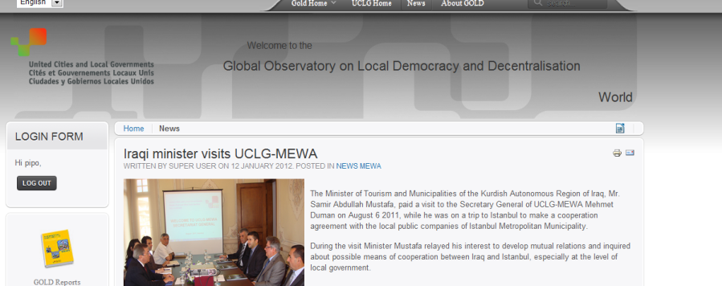

- If the user has just the “Registered” user group right, on validation of its article, the article will not be immediately published, but put in state “Unpublished”, in order to permits to an admin to check the article.
- An email is send to all Administrators of the web site to notify of a new article creation. Also there is notification on the top of the administrator pages.
- The article just created is put on the “News” category. The administrator will have to move the article to another category, according the topics discussed on the article “News Africa” for example.
- The administrator, will have to give the good alias to the article, if he change the category of the article.
- If the user has just the “Registered” user group right, he could edit only its articles. This time the article modification will be immediately published on the front end.

- Services management
Uclggold.org website has 4 services : Key Indicators, Country Profiles, Link Databases, Gold Report

  - Key indicators and link database management

Key indicators and link database contents are stored on mySql tables.

We have 5 tables :

region → contains the height regions name
theme → contains the theme description
organisation → contains the organisation name
countries → contains the countries description
linkdatabase → contains link database description

To add/delete/modify these tables, you can use the Joomla component JooDatabase.

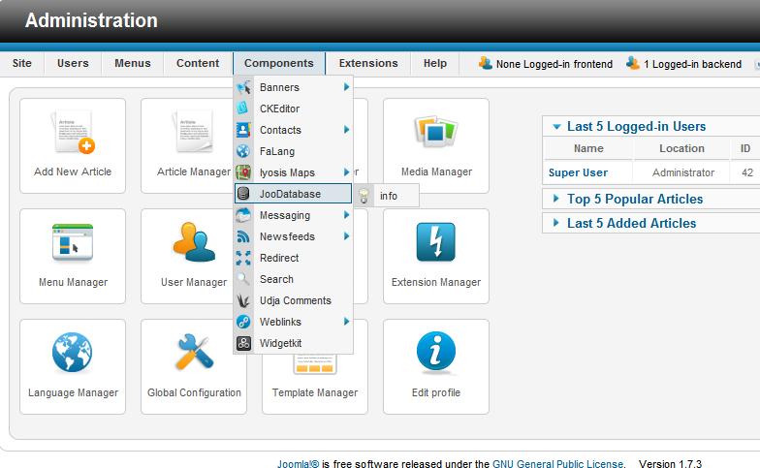
This component display the list of tables.
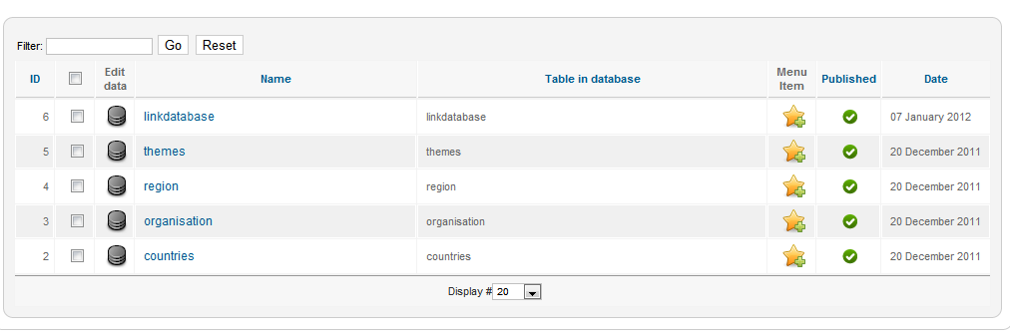

Select the edit icon of a table to modify its contents.

  - Country Profiles

The Country Profiles service consist of pdf files, each pdf corresponding to a country description.

There two pdf for each country :

- a pdf on the uclg gold web site permitting to visualize and download the pdf file.
- A issuu pdf file

The pdf file for a country must follow a naming convention permitting to discover its country name, and its region (Africa, Asia-Pacific, …)

naming convention for pdf file on :

- uclg gold web site : <country name>_<region number>.pdf
- issuu web site : <country name>.pdf

Example for Algeria country :

- uclg gold web site : Algeria_3.pdf
- issuu web site : Algeria.pdf

The region numbers is the following :

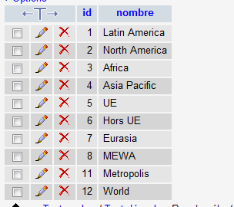

The pdf files for uclg gold web site is located on the directory :

/images/stories/pdf/country-profiles

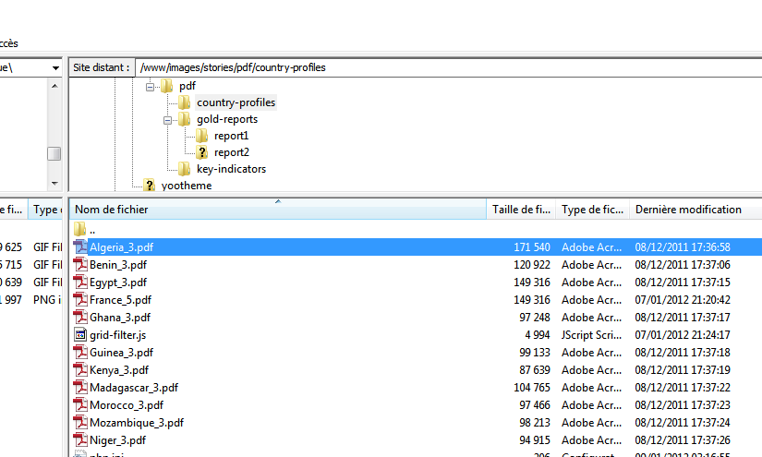

For issuu website, the pdf files are located under : http://issuu.com/uclggold/docs/

  - Gold Reports

A Gold Report is a Joomla article displaying accordingly some pdf files.

    - Naming conventions

A Gold Report must contains its region name in its alias name.

For exemple : gold-report-africa-1

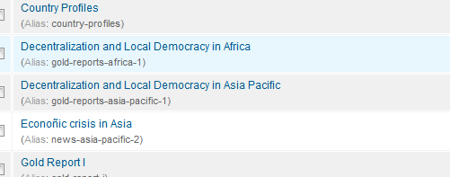

    - Displaying PDF contents

Two possibilities exist to display pdf contents :

- have a pdf for each section to display
- have a global pdf, and display only the section part of this pdf

case 1 :

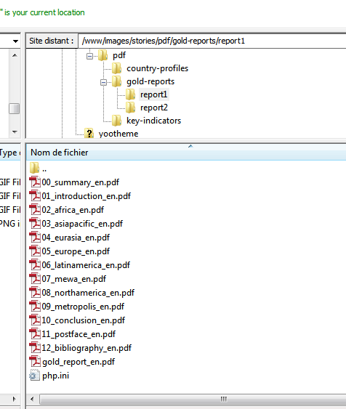

Case 2 :

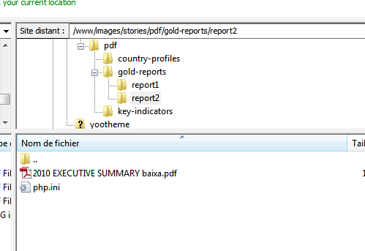

Case 2 is better if the pdf file is small.

    - Use multiples pdf
Article content :

<p>The 1 Global Report of United Cities and Local Governments (UCLG) on Decentralization and Local Democracy analyzes the architecture of fiscal ...
</p>
{loadposition Gold_Report_I_article}

The instruction {loadposition Gold_Report_I_article} invoke the Gold report 1 module

Gold Report 1 module content :

<?php
require_once("/home/uclggold/public_html/app/goldreports/gold_reports.php");

GoldReportHeader();

GoldReportPicture( "gold-reports-I.jpg", "gold_report_en");

GoldReportBeginChapter("report1/gold_report_en.pdf");
GoldReportChapter( "Executive Summary", "report1/00_summary_en.pdf");
GoldReportChapter( "Introduction", "report1/01_introduction_en.pdf");
GoldReportChapter( "Africa", "report1/02_africa_en.pdf", 'africa');
GoldReportChapter( "Asia Pacific", "report1/03_asiapacific_en.pdf", 'asia-pacific');
GoldReportChapter( "Eurasia", "report1/04_eurasia_en.pdf", 'eurasia');
GoldReportChapter( "Europe", "report1/05_europe_en.pdf", 'ue');
GoldReportChapter( "Latin America", "report1/06_latinamerica_en.pdf", 'latin-america');
GoldReportChapter( "Middle East and West Asia", "report1/07_mewa_en.pdf", 'mewa');
GoldReportChapter( "North America", "report1/08_northamerica_en.pdf", 'north-america');
GoldReportChapter( "Metropolis", "report1/09_metropolis_en.pdf");
GoldReportChapter( "Conclusions", "report1/10_conclusion_en.pdf");
GoldReportChapter( "Postface", "report1/11_postface_en.pdf");
GoldReportChapter( "bibliography", "report1/12_bibliography_en.pdf");

GoldReportEndChapter();

GoldReportFooter();
?>

    - Use one pdf

Article contents :

<p>The 2nd Global Report of United Cities and Local Governments (UCLG) on Decentralization and Local Democracy analyzes the architecture of fiscal decentralization ...
</p>
{loadposition Gold_Report_II}

No difference with the case 1, except the invocation to the Gold_report_II module.

Module contents

<?php
require_once( "/home/uclggold/public_html/app/goldreports/gold_reports.php");

GoldReportHeader();

GoldReportPicture( "gold-reports-II.jpg.png", "2010_executive_summary_baixa");

GoldReportBeginChapter("report2/2010_executive_summary_baixa");
GoldReportChapter( "Executive Summary", "report2/2010%20EXECUTIVE%20SUMMARY%20baixa.pdf", '', 8);
GoldReportChapter( "Editorial Project", "report2/2010%20EXECUTIVE%20SUMMARY%20baixa.pdf", '', 10);
GoldReportChapter( "Acknowledgments", "report2/2010%20EXECUTIVE%20SUMMARY%20baixa.pdf", '', 12);
GoldReportChapter( "Introduction", "report2/2010%20EXECUTIVE%20SUMMARY%20baixa.pdf", '', 14);
GoldReportChapter( "Africa", "report2/2010%20EXECUTIVE%20SUMMARY%20baixa.pdf", 'africa', 24);
GoldReportChapter( "Asia Pacific", "report2/2010%20EXECUTIVE%20SUMMARY%20baixa.pdf", 'asia-pacific', 30);
GoldReportChapter( "Eurasia", "report2/2010%20EXECUTIVE%20SUMMARY%20baixa.pdf", 'eurasia', 38);
GoldReportChapter( "Europe", "report2/2010%20EXECUTIVE%20SUMMARY%20baixa.pdf", 'ue', 44);
GoldReportChapter( "Latin America", "report2/2010%20EXECUTIVE%20SUMMARY%20baixa.pdf", 'latin-america', 52);
GoldReportChapter( "Middle East and West Asia", "report2/2010%20EXECUTIVE%20SUMMARY%20baixa.pdf", 'mewa', 60);
GoldReportChapter( "North America", "report2/2010%20EXECUTIVE%20SUMMARY%20baixa.pdf", 'north-america', 64);
GoldReportChapter( "Financing Metropolitan Cities", "report2/2010%20EXECUTIVE%20SUMMARY%20baixa.pdf", 70);
GoldReportChapter( "Conclusions", "report2/2010%20EXECUTIVE%20SUMMARY%20baixa.pdf", 76);
GoldReportEndChapter();

GoldReportFooter();
?>

The php fonction GoldReportChapter() use a second parameter which is the page number in the pdf document.

- Multilang

Use the Joomla component « falang » to translate articles, modules, menus, categories.
It's not mandatory to translate all. If there is no translation, the default language is used.
For doing a translation, don't use the Wysiwyg editor mode for the translation, but the raw mode.

- Joomla system administration

  - Joomla upgrade

Core Joomla files have been modified for UCLG Gold web site. So if a Joomla upgrade must be done, take care to update the modified files on the new Joomla release.

Also some components and modules have bean also , so take care when you update these components.

The Joomla template use is the Cloud Yootheme theme.

  - Joomla Configuration

    - Cache management
UCLG Gold web site is a dynamic web site, and context oriented web site. That mean a same url could give different results according the region selected (News and Gold Reports section for example).
That mean we can't enable the Joomla cache.

    - URL rewriting
The website use url rewriting. So don't remove this option on the configuration page.

  - Joomla extensions
Here we describe the list of Joomla extension used by uclggold website not provided by a standard Joomla installation.

      - Components extension

- JooDatabase : Permits to manages the mySQL tables

- CLKEditor : Wysiwyg editor. Better than Joomla standard editor.

- Udja Comments : Permit to have comments on articles

- Widgetkit : Components for the banners and also “Next Event” in Asia-Pacific region.

- IyosisMap : Map of the front page of World section.

      - Plugins extension
- DirectPHP : Permits to insert php code directly to Joomla articles or custom modules

- Qlue Tooltip : Permits to have a tooltip information above a text.

      - Modules extension
Aida2 News : Permit to have the latest news

    - ExtJS
ExtJS is a javascript library used by the uclg gold services, to display the grids.
The release used is the 4.0.
This library is installed directly under the website root directory.

- Banners update

The banners are located under the directory images/stories/banner.

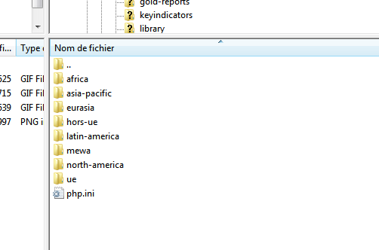

This directory contains height directories corresponding to the height regions. In each of these directories, we have the banner pictures.

For example for UE region (Europe), we have the files :

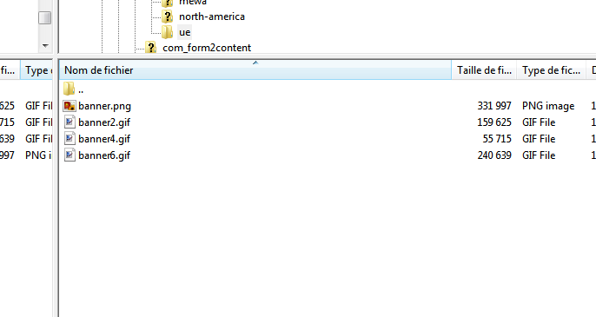

To add a file, we have just to put the file to the correcponding ftp directory.
To delete or modify a file, we have to modify and update on the ftp directory, and also remove the Joomla cache contents :

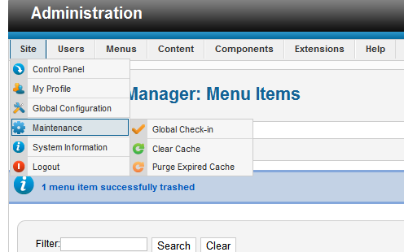

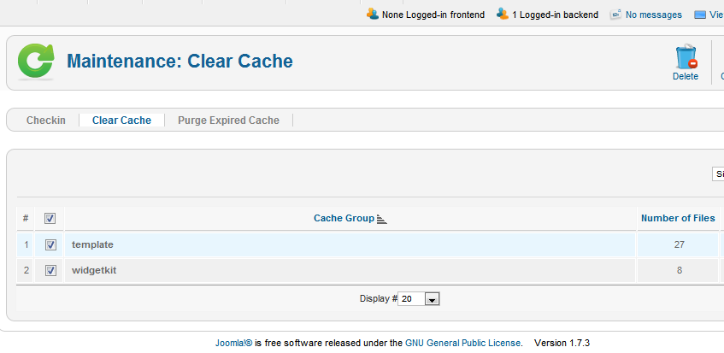

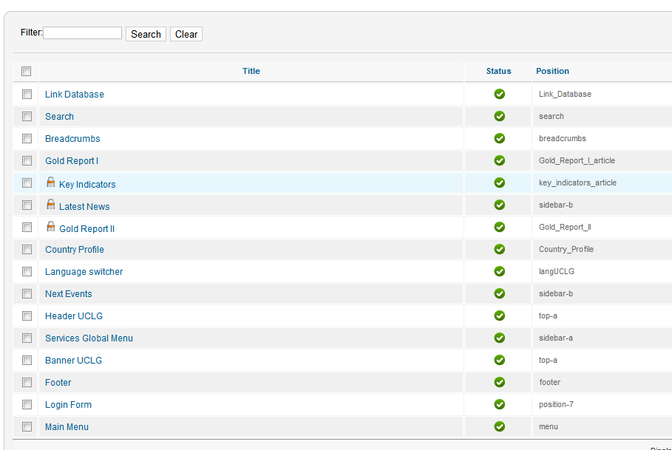

- Implementation

  - Services oriented PHP code
The code to manage services (Gold Report, Key Indicators, Country Profile, Link database) is located under the ftp directory app :

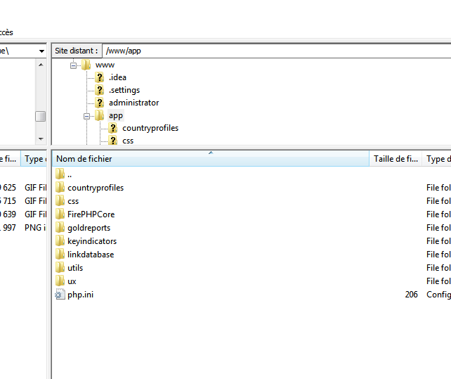

Directory countryprofiles is for service “Country Profile”, goldreport for service “Gold Report”, keyindicators for service “Key Indicators” and linkdatabase for service “Link Database”.

Others directories are utilities directories.

  - Regions management

In order to simplify the administration of the website, the management of the regions has been abstracted more possible, permitting to have modules independent of regions.

The management of regions has been handled on sublayer, inside the modules and services implementation.

This abstraction is also obtained by using naming conventions for categories and articles.

    - Categories list

Here is the categories of uclggold web site :

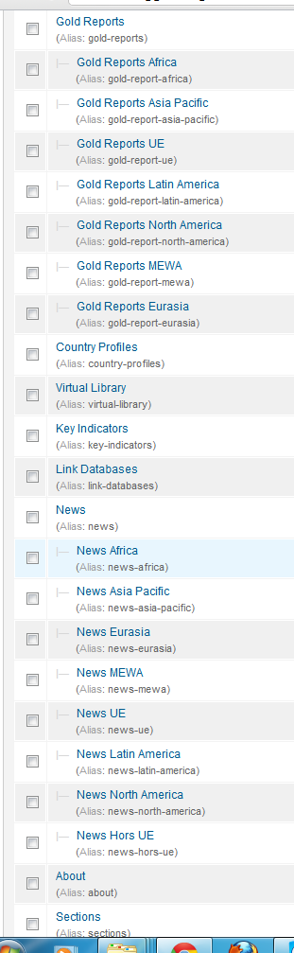

Category “Gold Report” and “News” contains region subcategories, because there is articles corresponding to these categories.
When a administrator or publisher create a Gold Report” or “News” article, he has to say in what category this article pertain.

Remark : It would be possible to have only a “Gold Report” and “News” category to display correctly the articles according the region selected, using the naming convention, but then we lost the articles right management for the administrators. So we keep the hierarchy.

